**STUDY OF UNIX OPERATING SYSTEM AND ITS FUNDAMENTALS**

**Operating system-**

An operating system (OS) is the program that, after being initially loaded into the computer by a boot program, manages all of the other application programs in a computer. The application programs make use of the operating system by making requests for services through a defined application program interface ([API](https://www.techtarget.com/searchapparchitecture/definition/application-program-interface-API)). In addition, users can interact directly with the operating system through a user interface, such as a command-line interface (CLI) or a graphical UI (GUI).



**LIST OF OPERATING SYSTEM WITH THEIR UTILITY-**

**1. MS-DOS:**

MS-DOS which is short for Microsoft Disk Operating System is a non-graphical command line operating system developed for IBM compatible computers with x86 microprocessor. The operating system used a command line interface for the user to input commands to navigate, open and manipulate files on their computer.

**FEATURES**

* It is a single user operating system meaning only one user can operate at a time..
* It is very helpful in making file management like creating, editing, deleting files, etc.
* It also controls and manages other external devices such as the printer, keyboard or external hard drive using various drive utilities.
* **2. Windows Operating System:**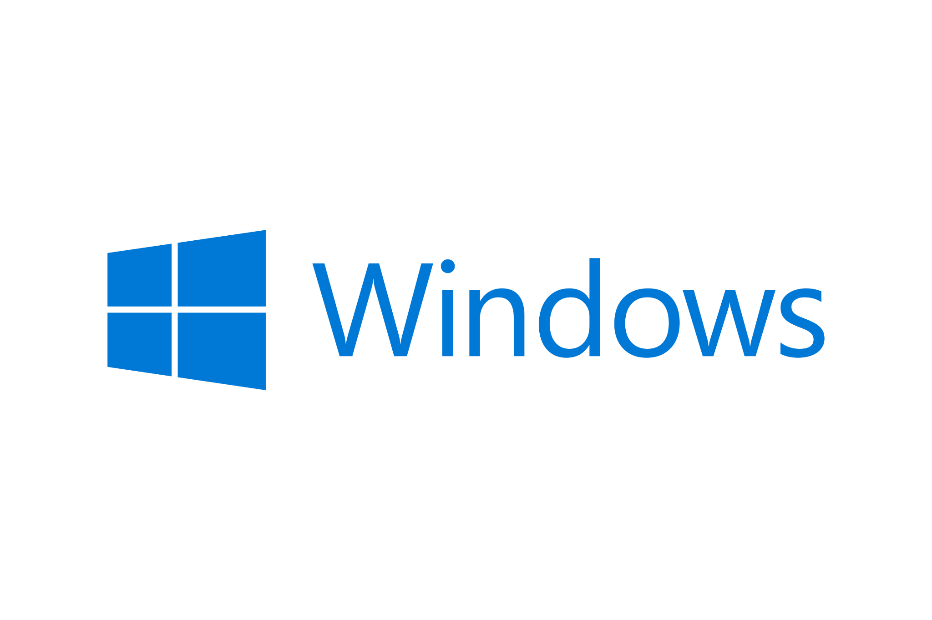  
  Windows is an operating system designed by Microsoft to be used on a standard x86 Intel and AMD processors. It provides an interface, known as a graphical user interface(GUI) which eliminates the need to memorize commands for the command line by using a mouse to navigate through menus, dialog boxes, buttons, tabs, and icons.
* It is designed to run on any standard x86 Intel and AMD hence most of the hardware vendors make drivers for windows like Dell, HP, etc.
* It supports enhanced performance by utilizing multi-core processors.
* Windows is backward compatible meaning old programs can run on newer versions..

**3. LINUX Operating System: **The Linux OS is an open source operating system project that is a freely distributed, cross-platform operating system developed based on UNIX. This operating system is developed by Linus Torvalds. The name Linux comes from the Linux kernel. It is basically the system software on a computer that allows apps and users to perform some specific task on the computer. The development of Linux operating system pioneered the open source development and became the symbol of software collaboration.

* Linux is free can be downloaded from the Internet or redistribute it under GNU licenses and has the best community support.
* Linux OS is easily portable which means it can be installed on various types of devices like mobile, tablet computers.
* Linux provides user security using authentication features and also threat detection and solution is very fast because Linux is mainly community driven.

**4. iOS Mobile Operating System:**

iOS which is short for iPhone OS is a mobile operating system created and developed by Apple Inc. exclusively for its hardware like A12 Bionic chip that presently powers many of its mobile devices, including the iPhone, iPad, and iPod. The iOS user interface is based upon using multi-touch gestures such as swipe, tap, pinch, and reverse pinch. The purpose of these finger actions is to provide the user with fast responsive inputs given from multiple fingers to the multi-touch capacitive screen display.

* It is written in C, C++, Objective-C and Swift and is based on the Macintosh OS X.
* iOS comes with a lot of default apps, including an email client, web browser, media player and the phone app.
* iOS is much safer than other mobile operating systems and has fewer security breaches as well.

**About unix operating system-**

**Unix OS**

Unix is an Operating System that is truly the base of all Operating Systems like Ubuntu, Solaris, POSIX, etc. It was developed in the 1970s by Ken Thompson, Dennis Ritchie, and others in the AT&T Laboratories. It was originally meant for programmers developing software rather than non-programmers.

## **Some of the key features of UNIX include:**

1. Multiuser support: UNIX allows multiple users to simultaneously access the same system and share resources.
2. Multitasking: UNIX is capable of running multiple processes at the same time.
3. Shell scripting: UNIX provides a powerful scripting language that allows users to automate tasks.
4. Security: UNIX has a robust security model that includes file permissions, user accounts, and network security features.
5. Portability: UNIX can run on a wide variety of hardware platforms, from small embedded systems to large mainframe computers.

## **Unix OS Distribution**

1. Ubuntu: Known for its user-friendliness and strong community support, Ubuntu is a great choice for beginners.
2. Fedora: A cutting-edge distribution sponsored by Red Hat, often used by developers and enthusiasts.
3. Kali Linux: Designed for cybersecurity professionals and ethical hackers, it comes with a wide range of security tools pre-installed.
4. macOS: macOS, developed by Apple Inc., is built on a Unix-based foundation called Darwin. It features a user-friendly graphical interface and is known for its integration with Apple hardware and software.
5. FreeBSD: FreeBSD is a Unix-like operating system known for its focus on performance and advanced networking capabilities. It's often used in server environments.
6. OpenBSD: OpenBSD is a Unix-like operating system with a strong emphasis on security and correctness. It's used in security-critical applications.
7. Solaris: Solaris, developed by Sun Microsystems (now part of Oracle), is a commercial Unix-based operating system known for its scalability and features like ZFS and DTrace.

**HISTORY-**

Unix is an Operating System that is truly the base of all Operating Systems like Ubuntu, Solaris, POSIX, etc. It was developed in the 1970s by Ken Thompson, Dennis Ritchie, and others in the AT&T Laboratories. It was originally meant for programmers developing software rather than non-programmers.

Unix and the C were found by AT&T and distributed to government and academic institutions, which led to both being ported to a wider variety of machine families than any other operating system. The main focus that was brought by the developers in this operating system was the Kernel. Unix was considered to be the heart of the operating System. System Structure of Unix OS are as follows:

## **Application of Linux**

1. Server Administration: Unix is the foundation for many server operating systems, such as Linux distributions, FreeBSD, and Solaris. It's widely used for web servers (e.g., Apache), database servers (e.g., MySQL, PostgreSQL), and cloud infrastructure management.
2. Development and Programming: Unix is a favorite among developers and programmers. It provides powerful command-line tools, development environments (e.g., GCC), and scripting languages (e.g., Bash, Python) for software development.
3. Networking: Unix-based systems offer robust networking capabilities, making them ideal for routers, firewalls, and networking equipment. The TCP/IP stack, essential for internet communication, was developed on Unix.
4. System Administration: Unix's multi-user, multi-tasking capabilities make it well-suited for system administrators managing large networks, user accounts, and security configurations.
5. Web Development and Hosting: Unix-based servers, especially Linux, dominate web hosting. Popular content management systems (e.g., WordPress) and web frameworks (e.g., Ruby on Rails) run on Unix.
6. Embedded Systems: Unix-like systems can be scaled down and adapted for use in embedded systems, such as routers, IoT devices, and industrial automation.
7. Education: Unix is often used in computer science and IT education to teach fundamental concepts like file systems, process management, and network protocols.
8. Creative Arts: Unix-based systems like macOS are popular among creative professionals for tasks such as graphic design, video editing, and music production.

**Comparison of windows and unix-**

### 1. Licensing:

UNIX was developed as an open-source OS using C and Assembly languages. Since being open source UNIX, and its various Linux distributions account for the most used OS in the world. Unix and all its Linux distributions are available under the General Public License.

Windows Operating System is proprietary software owned by Microsoft, meaning its source code is not available to the public.

### 2. User Interface:

Unix operating systems are relatively harder to grasp and produce significant barriers for newcomers. However, some Linux distributions like Ubuntu are changing such perceptions by bringing in more GUI-based applications.

Windows Operating System on the other hand is designed with the outset of keeping the UI as simple and user-friendly as possible, so that non-IT people can easily use computers for their work.

### 3. Processing:

UNIX operating system supports Multiprocessing, meaning many processes are executed simultaneously. In Multiprocessing, every process has a separate address space and CPUs can be added for increasing computing power.

Windows Support Multithreading, meaning many threads are created from a single process for increasing computing power. In multithreading, many threads of a process are executed simultaneously where common address space is shared by all the threads.

### 4. File System:

UNIX operating system uses STD.ERR and STD.IO file systems or the UFS (Unix File System) and treats all physical drives as one logical drive. It has a robust and efficient file system. File system is represented as a hierarchical tree under the same root.

Windows on the other hand, uses File Allocation Table (FAT32) and New Technology File System(NTFS) systems for managing files and requires the owner of the executables before executing, files store in folders on different data drive like, C,D,E.

### 5. Security:

UNIX is more secure by design. The primary protection on a Unix system is that executing a “.exe” file is much more difficult. Here executables cannot be processed without explicit permission as all processes in Unix are treated equally. But these are slowly changing as Unix distributions are moving more towards GUI and now relying on the application security itself.

Another advantage of Unix systems is that getting rid of viruses is easier, as viruses can only infect user accounts and the root remains intact and pure.

Windows is less secure in the sense that it is simple to execute files with minimal permission. These can further lead to the installation of Malwares unknowingly on the system.